Final Year Project

Human Emotions

Feelings are complicated. As we learned from the classic treatise on psychology, [Inside Out](https://www.youtube.com/watch?v=yRUAzGQ3nSY), it is possible to feel two things at once. But it’s also possible to not understand how we’re feeling or what to do about it.

That makes sense — after all, [human beings can experience over 34,000 different emotions](https://www.jstor.org/stable/27857503). That’s a lot to keep track of, and it’s certainly a lot to feel. More conservative estimates [identify 27 distinct emotional states](https://greatergood.berkeley.edu/article/item/how_many_different_human_emotions_are_there) — but even that is a lot to sift through. Even the most dedicated journaler would have trouble sorting that out.

To understand what’s happening beneath the surface, psychologist Robert Plutchik, Ph.D., simplified the range of human feeling into the emotion wheel. It depicts 8 core emotions that are at the heart of our experiences, reactions, and sensations.

**What is an emotion wheel?**

An emotion wheel is a circular graph that depicts the range of human emotions and how  they relate to one another. Created by psychologist Robert Plutchik, Ph.D., most modern versions of the emotion wheel have 8 core emotions at the center. These are joy, fear, surprise, anger, trust, sadness, disgust, and anticipation.

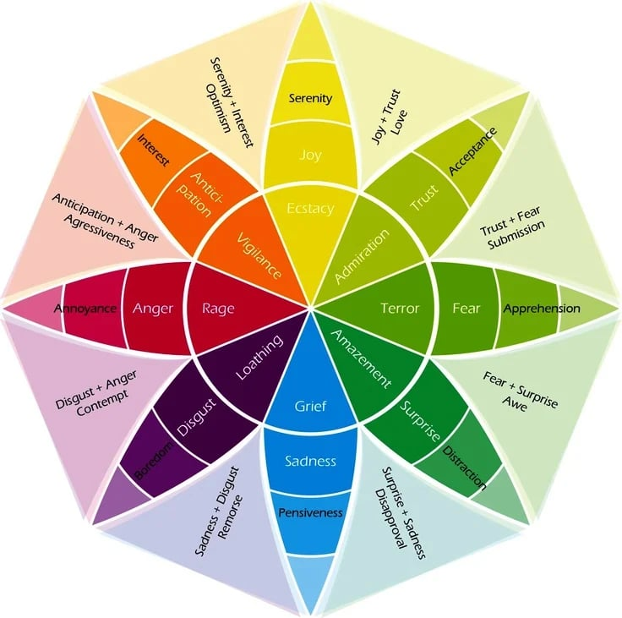

Emotion wheels are usually shaped like colorful flowers. In the center are our basic emotions: **sadness**, **disgust**, **anger**, **anticipation**, **joy**, **fear**, **surprise**, and **trust**. Radiating toward the outer edges are less intense variants of these core emotions. For example, when you feel irritation, it’s a milder form of anger.

Here’s a detailed look at primary and secondary emotions:

* **Sadness:**includes grief, pensiveness, regret, hurt, rejection, melancholy, discouragement, and depressed
* **Disgust:**includes hatred, disinterest, disapproval, revulsion, dismissiveness, repulsion, and critical
* **Anger:** includes rage, irritation, frustration, insulted, bitterness, mocked, violated, jealous, offended, and provoked
* **Anticipation:** includes interest, vigilance, excitement, awareness, impatience, expectant, harried, and cautious
* **Joy:** includes happiness, ecstasy, elation, pleasure, triumph, satisfaction, contentment, pride, and serenity
* **Fear:** includes terror, caution, apprehension, concern, worry, anxiety, stressed, and nervous
* **Surprise:**includes amazement, distraction, wonder, awe, amusement, shock, speechlessness, and disbelief
* **Trust:**includes safety, vulnerability, hopeful, positive, secure, supported, comfortable, and relaxed

In everyday interactions, we naturally make use of these distinctions to pinpoint our feelings.

Have you ever had a conversation with someone that sounded like this:

* **Person:** “You must be really sad that it didn’t turn out the way you wanted.”
* **You:** “No — I’m not really sad, just disappointed.”

Some versions of the emotion wheel show our feelings in much more detail. For example, this version of the emotion wheel shows only six core emotions — only negative ones — but far more secondary emotions. You might notice that “small” appears as a subset of both shame and sadness.

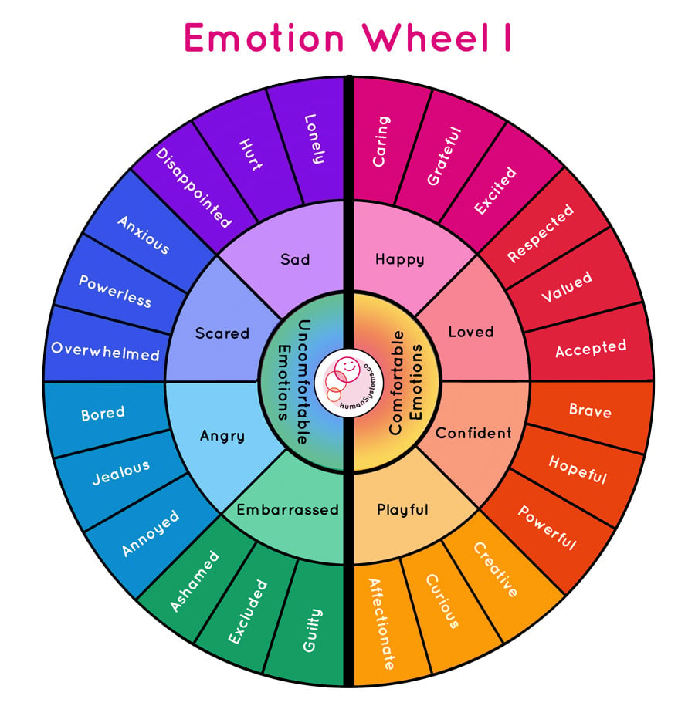

References:

https://www.betterup.com/blog/emotion-wheel

<https://cdn.jsdelivr.net/gh/nucular/mmpi-2@c7456d4bc33a8f355ad63fc0424aeac29e70a2f6/index.html>